**Was Palestine an ‘empty land’ in the nineteenth century?**

**Lesson 1**

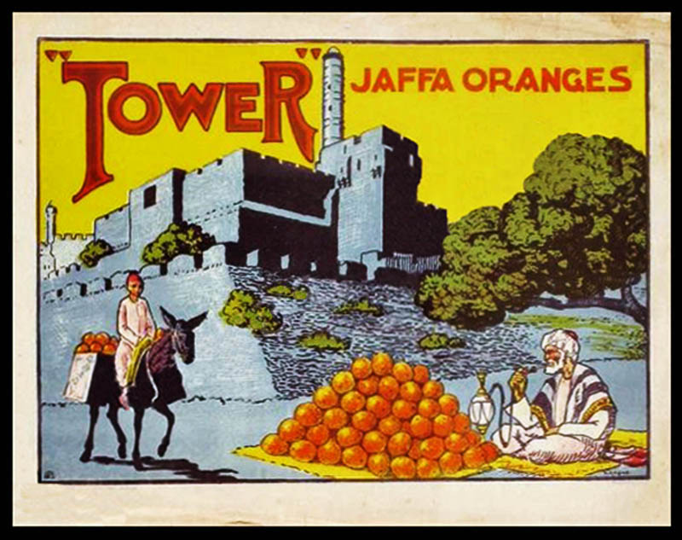

**By the end of this lesson, you should be able to:**

Define Palestine-Israel and locate it on a map

Describe what life was like in Palestine in the nineteenth century

Assess the statement that Palestine was an ‘empty land’ in the nineteenth century

**Keywords**

Ottoman Empire

Palestine-Israel

Modernisation

**Knowledge check!**

1)What three words come to mind when you hear ‘Palestine-Israel’?

2)Can you remember a time when you have seen Palestine-Israel in the news?

3)What do you want to know about Palestine-Israel? Write down two questions

**Palestine-Israel**

Also referred to as Israel/Palestine. This is the land between the Mediterranean Sea and the River Jordan

**True or false?**

We will come back to these statements throughout the course

**Palestine through history**

The land of Palestine-Israel (Israel and the occupied Palestinian territories of the West Bank and Gaza) is rich in history. The use of the word ‘Palestine’ to describe the land between the Mediterranean Sea and the River Jordan can be traced back to 450 BCE – that’s **nearly** **2500 years ago!** Since then, the land of Palestine-Israel has been ruled by Romans, Muslims, Christian crusaders and Ottomans. The land has always been popular because it has **strategic and religious significance**, as we’ll see. Through all of this, the Palestinian people have had close ties to the land

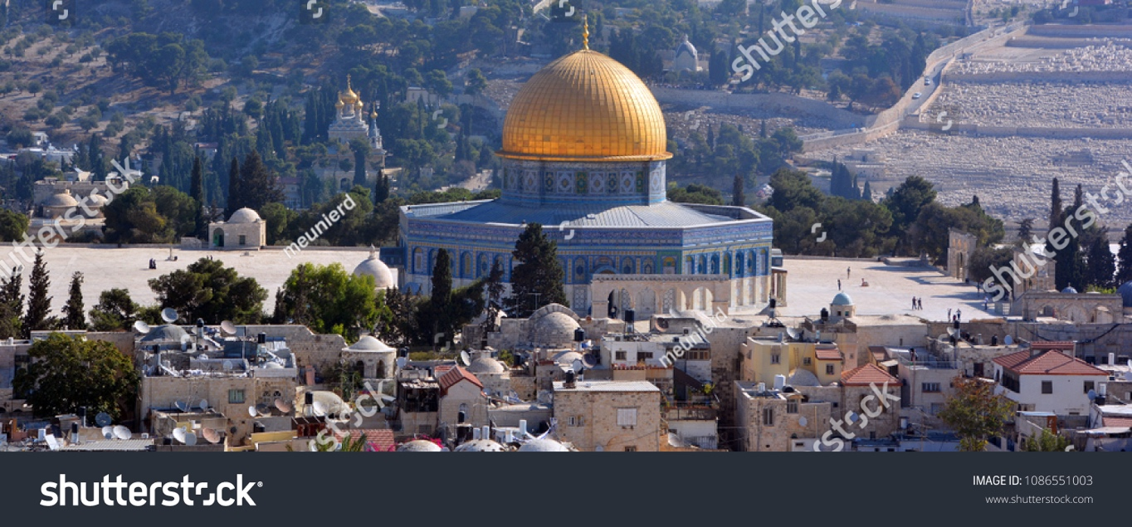

**The city of Jerusalem**

Jerusalem is Palestine-Israel’s capital city, and it has huge **religious significance**. Regarded by many as **one of the holiest places in the world**, Jerusalem is important to Jews, Christians and Muslims for different reasons

For Jews, all of creation began in Jerusalem. The Western Wall in the Old City of Jerusalem is **the** **holiest place where Jews can pray**. It was in Jerusalem that King Solomon built the First Temple to house the Ark of the Covenant, a sacred chest that contained the Ten Commandments. It was also where Abraham showed that he was prepared to sacrifice his son

For Christians, Jerusalem is where **Jesus preached, celebrated his Last Supper, died by crucifixion, and was resurrected by God.** The holiest site on earth for many Christians is the Tomb of Christ in the Church of the Holy Sepulchre in the Old City of Jerusalem

For Muslims, Jerusalem is where the prophet Muhammad **ascended to heaven**. The Al-Aqsa Mosque, built on top of the Dome of the Rock in Jerusalem, is the third holiest site in Islam after Mecca and Medina

**Activity**

Write three sentences explaining the significance of Jerusalem to:

Muslims

Christians

Jews

**Question**

What do you imagine an ‘empty land’ to look like?

**Nineteenth century Palestine**

For nearly 400 years from 1517 until the early 1900s, Palestine-Israel was part of the **Ottoman Empire**. This was a large empire that spanned from South-eastern Europe and Western Asia to North Africa, with Constantinople (now **Istanbul**) as its capital

In the past, historians have thought that the Ottoman Empire was falling apart in the nineteenth century. But new research has shown that actually, the Ottoman Empire was going through a period of **rejuvenation** in the nineteenth century

Palestine-Israel is just one part of the Ottoman Empire that flourished in the 1800s. **Improvements to life** took place at a political, economic and social level

**Activity**

Create a spider diagram of life in nineteenth century Palestine

**Politics**

As part of the Tanzimat Reforms of the 1840s, local government was improved to include some councils that were representative of the population

**Economics**

The Palestinian economy experienced a significant boom in the nineteenth century. There was a rapid increase in agricultural output including citrus fruits, olive oil, sugar cane, sesame seed, apples and grapes, much of which was traded with nearby regions and Europe. Palestine produced over 2 million kilograms of cotton in the 1830s alone, around 75% of which was exported! This **modernisation** made the Palestinians in both rural and urban areas richer

**Social**

Most Palestinians at this time were Muslims who lived in the countryside doing agricultural work. Palestine had approximately 1000 villages at this time. Wealthier Palestinians lived in the towns and cities such as Jerusalem, Haifa, Tiberias and Acre

Throughout the nineteenth century, new services were developed in education and health. There was also increasing discussion about the position of women in Palestine and Arab society more generally, particularly at the end of the 1800s. More women started to receive an education and work outside the home

**Check your knowledge!**

Define Palestine-Israel

Describe three features of life in nineteenth century Palestine

**Extension question**

To what extent was Palestine an ‘empty land’ in the nineteenth century? Remember to justify and contextualise your answer